**1.** Consider the column 'diesel'; what should the value for Car B be?

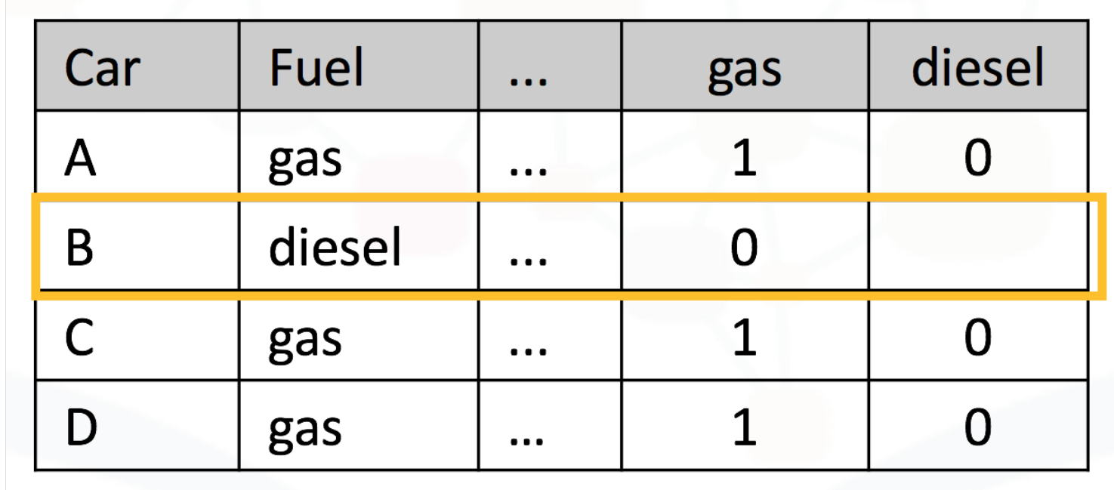

* 1
* 0